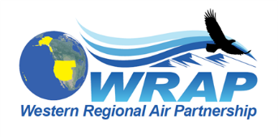

Regional Technical Operations Work Group

February 12, 2019 Agenda

Welcome, Roll Call, Note-taking duties – Mike, Gail, Kevin

Options for adjusting Uniform Rate of Progress Glide path - Pat Brewer
- EPA webinar on February 20th from 2:00-3:30 EST to review and take questions on the recently released “Technical Guidance on Tracking Visibility Progress for the 2nd Implementation Period of the Regional Haze Program.” Use this link to connect to the webinar: https://epawebconferencing.acms.com/reghaze. The webinar will be conducted on-line only, with audio through computer speakers. Questions can be submitted in writing through the webinar interface. The guidance document can be found here: https://www.epa.gov/visibility/technical-guidance-tracking-visibility-progress-second-implementation-period-regional. The guidance includes EPA’s recommendations on 1) methods for selecting the 20 percent most impaired days to track visibility and determining natural visibility conditions; and 2) methods for accounting for total international impacts to adjust the uniform rate of progress (i.e., the URP glidepath) for the second implementation period.
Status of 2014 Phase I Shakeout Modeling Platform study - Ralph Morris

- 2014 Shakeout Modeling Platform results meeting, downtown Denver, April 2 - Tom

Progress on Workplan revisions for Appendix E – Tom Moore

Next call (mid-March) - Mike, Gail, Kevin

